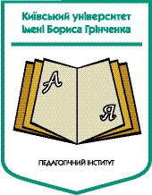
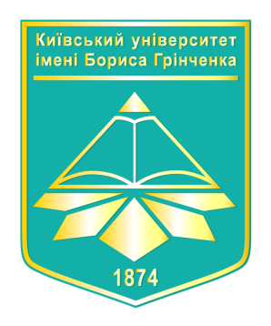
Borys Grinchenko Kyiv University
Pedagogical Institute
Foreign languages and methodology Department

The VII Annual Scientific and Practical Conference
«Modern Foreign Languages Education. The Students` View»



27 March 2018
10.00 – 10.25 Conference opening (Room 201)
Welcome Foreign Languages and Methodology Department
Plenary (Room 201)
Plenary section moderators: I. Pluzhnyk

NETWORKING BLOCKS
10.30 – 12.30

Room 209  «ENGLISH  IN EDUCATION»  Yuliia Labunets  Olga Maksyumiuk | Room 222  «ENGLISH  IN WORK»  Olga Sytnyk  Vira Prokhorchuk
Room 205  «ENGLISH IN  SELF-DEVELOPEMENT»  Iryna Pluzhnyk  Valeria Naumets | Room 201  «ENGLISH IN  ENTERTAINMENT»  Tetiana Holovatenko  Tamara Zahladko

NETWORKING BLOCKS | Yuliia Labunets`  Senior lecturer of Borys Grinchenko Kyiv University Foreign Languagues and Methodology Department.  Olga Maksyumiuk  A student of Institute of Art (specialty “Musical Art”) | «ENGLISH IN EDUCATION»  Each of us has a great experience in learning English, but rather often we face a challenge how to say something correctly or how to share our opinion without getting into a trouble. If you want to open new opportunities for yourself in organizing your studying environment in English you should definitely attend this networking block; it is aimed to help you feel your involvement into educational process by studying English.
NETWORKING BLOCKS | Olga Sytnyk  Senior lecturer of Borys Grinchenko Kyiv University Foreign Languagues and Methodology Department.  Vira Prokhorchuk  A student of Pedagogical Institute (specialty “Pre-school Education”)  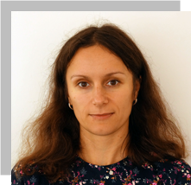 | «ENGLISH IN WORK»  How to find a good job? What are the tips for that? How to succeed in this field? Job interview is the procedure which helps the employer to take a right choice forming the professional staff as well as the employee makes a career getting a new job. Let’s take the lead of and overcome this challenge during our networking block.
NETWORKING BLOCKS | Iryna Pluzhnyk  Lecturer of Borys Grinchenko Kyiv University Foreign Languagues and Methodology Department.  Valeria Naumets  A student of Pedagogical Institute (specialty “Pre-school Education”)   | - «ENGLISH IN SELF-DEVELOPMENT»  From time to time educators face the internal need to find the most optimal way to increase their personal and professional positions. Today, we invite you to feel what is in time in the modern educational environment and how you can use the latest educational trends to achieve your personal goals. At the center of our interaction is the issue of self-education and life-long education in order to achieve personal and professional harmony.
NETWORKING BLOCKS | Tetiana Holovatenko  Lecturer of Borys Grinchenko Kyiv University Foreign Languagues and Methodology Department.  Tamara Zahladko  A student of Pedagogical Institute (specialty “Primary Education”) | - «ENGLISH IN ENTERTAINMENT»  Entertainment is a part of our life because we need to rest after a busy working or studying day. So, do you like playing games? Have you ever played board games or card games in English? No...? We are going to learn how to use different games to learn English efficiently and how to use them in education. We will equip ourselves with a range of techniques suitable for different ages. Let`s have some fun!

